CHAPTER III-DIGITAL LOGIC LEVEL

3.4 CPU CHIPS and BUSES

CPU communicates with other devices through its pins: address, data and control pins

Key parameters that determine the performance of CPU:
  - the number of address lines
  - the number of data lines

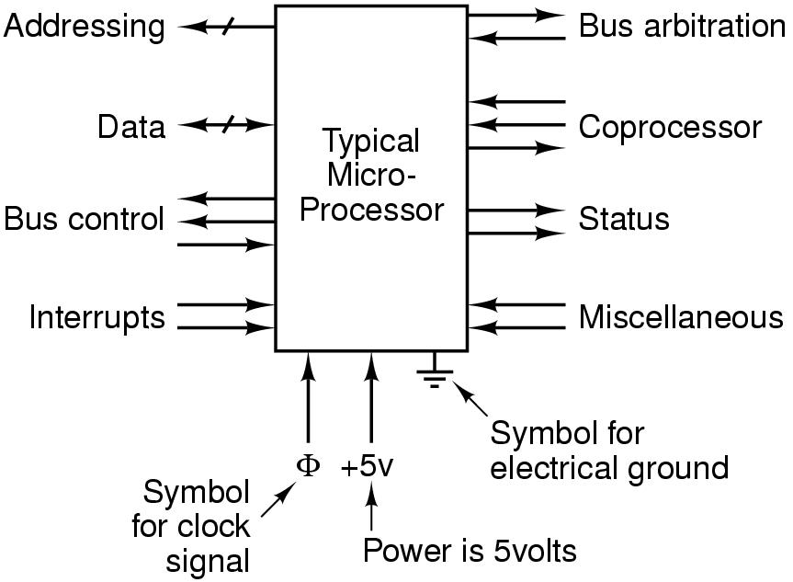

3.4.2 COMPUTER BUSES

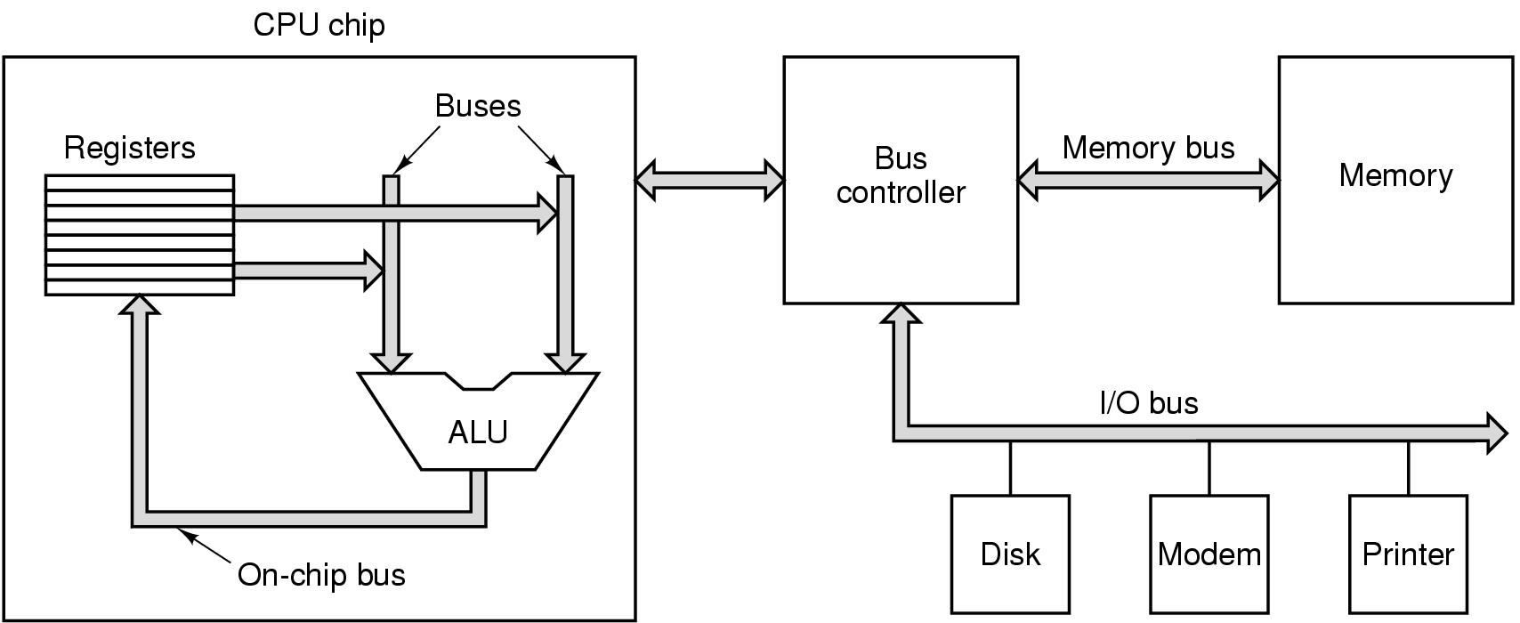

Bus protocol: In order to make it possible for boards designed by 3rd parties to attach to the system bus, there must be well defined rules about how the bus works and which all devices attached to it must obey.

Omnibus, unibus, multibus, IBM PC bus, ISA, EISA, Microchannel, PCI , SCSI, Nubus, USB, FireWire, VME…

Master: active devices that initiate bus transfers

Slave: passive devices

Bus driver: The binary signals that computer devices output are frequently not strong enough to power a bus, especially if it is relatively long or has many devices on it. For this reason, bus masters are connected to the bus by a chip called bus driver.

Bus receiver: Most slaves are connected to bus by a bus receiver

Bus tranceiver: For devices that can act as both master and slave.

Bus drivers, bus tranceivers, bus receiver: tri-state devices

Decoder: There is not necessarily a one-to-one mapping between the CPU pins and the bus signals.

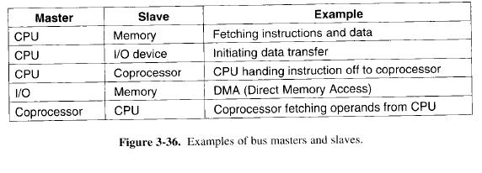

Bus Design Issues:
- Bus width
- Bus clocking
- Bus arbitration
- Bus operation

- Bus width:

n address lines, 2^{n} different memory locations
Wide buses need more wires than narrow ones. They take up more physical space. They need big connectors anda re more expensive. There is a trade off between maximum memory size and system cost

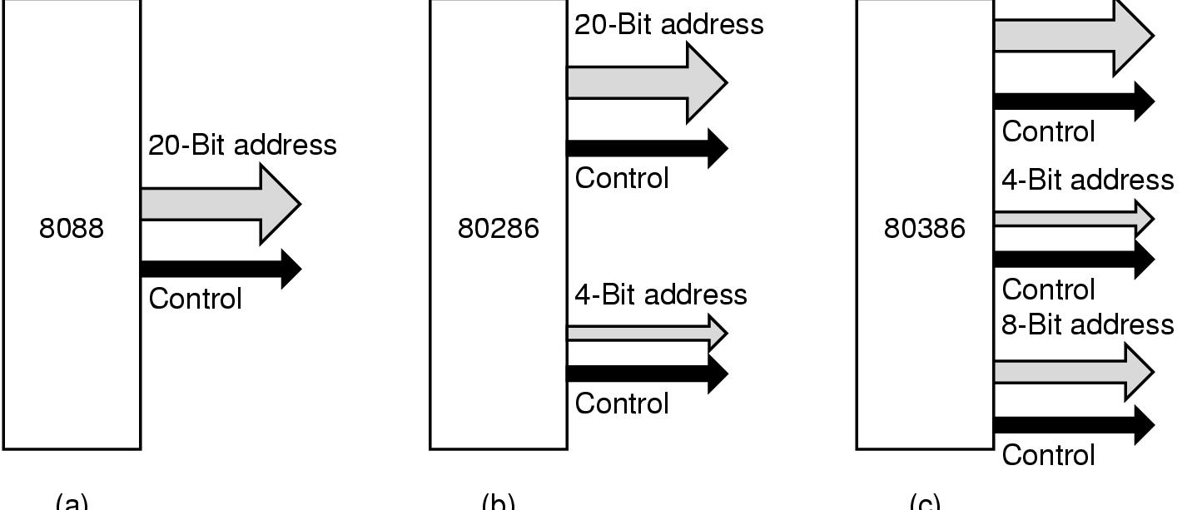

IPM PC: 20 bit address bus -> 1 MB memory
80286: + 4 bit addr. Lines + ctrl -> 16 MB memory
80386: + 8 bit addre. Lines + ctrl (EISA bus)

Not only does the number of address lines tend to grow over time, but so does the number of data lines, but somewhat different reason. There are two ways to increase the data bandwidth of a bus:

- decrease bus cycle time
- Bus skew becomes a greater problem when bus gets faster (Bus skew: signals on different lines travel at slightly different speeds)
- Not backward compatible
- add more data lines: preferred approach

Multiplexing bus: a solution to get around the problem of very wide buses

- Bus clocking:
- Synchronous bus: driven by a crystal oscilaltor
ISA bus: 8.33 MHZ
PCI bus: 33 MHZ or 66 MHZ
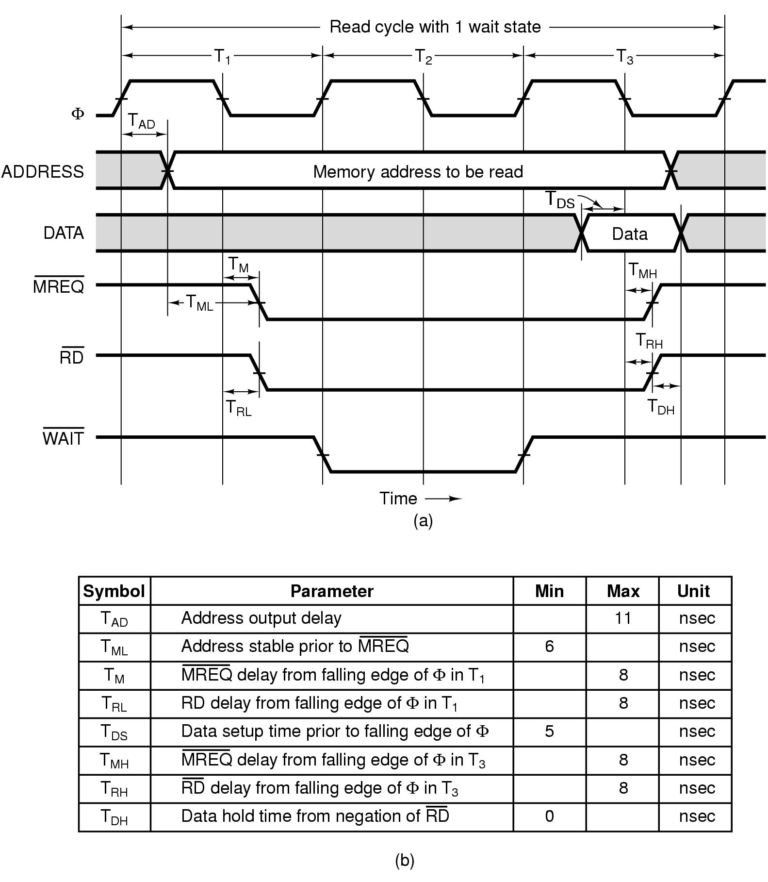

- Asynchronous bus: does not have a master clock

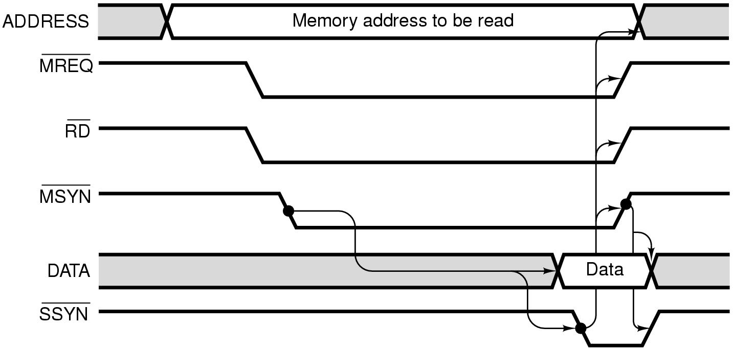

In synchronous bus:
- Eveything works in multiples of the bus clock.
- A few years after the system was built, new memories became available with access time of 8 nsec instead of 15 nsec. These would get rid of the wait state, speeding up the machine. Suppose 4 nsec memories became available. There would be no further gain in performance because the minimum time for a read is 2 cycles.

In a synchronous bus, heterogenous collection of devices, some fast and some slow, the bus has to be geared to the slowest one and the ones cannot use their potential. Solution: handshaking

- Most buses are synchronous. It is easier to built a synchronous system. A lot of investment in sysnchronous bus technology.

- Bus Arbitration:

What happens if 2 or more devices all want to become bus master at the same time?

PCI Bus Arbitration:

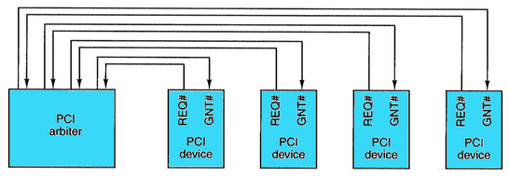

- Bus operation
- block transfer
- read-modify-write cycle for multiprocessor systems
- interrupts

Block Transfers:
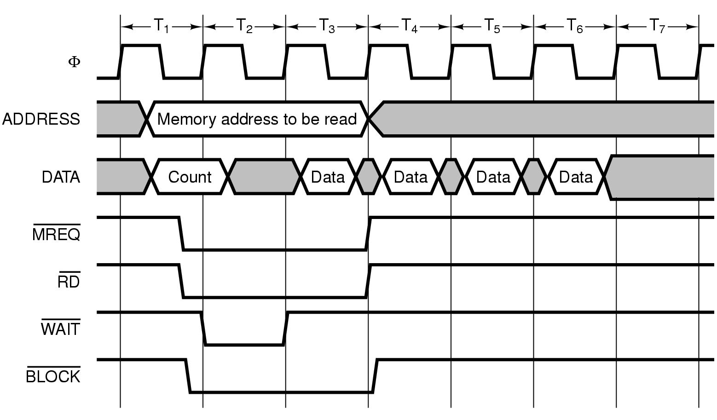

İnterrupts:

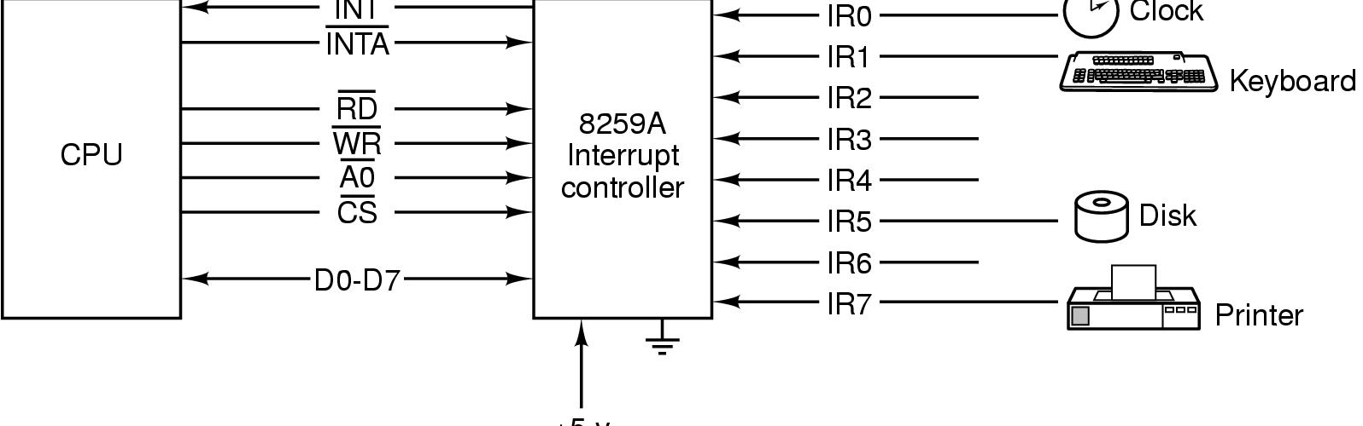

3.5 EXAMPLE CPU CHIPS

3.5.1 Intel Core 7
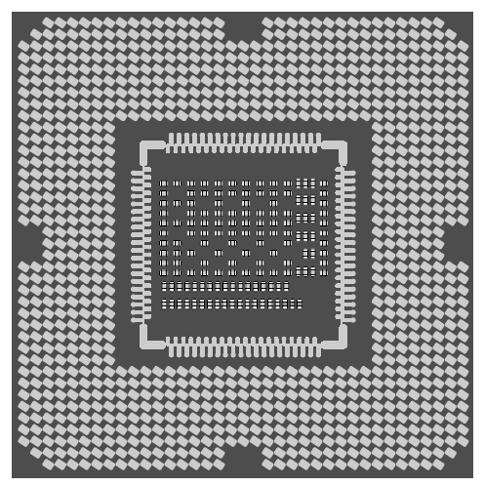

- introduced in 2008, descendant of 8088 (29000 transistors)
- A 4 core 731 million transistor CPU, 3.2 GHz, 45 nanom. linewidth
- Currently Haswell architecture:
https://en.wikipedia.org/wiki/List_of_CPU_power_dissipation_figures
- Software view:
  - 64 bit machine
  - The same user level ISA with 80386, 80486, Pentiums
  - New instructions for cryptographic operations
- Hardware level:
  - Based on Core 2 and Core Duo 2
  - 4-wide superscalar architecture: upto 4 instructions at once
  - 3 levels of cache:
    - Each core: 32 KB Level 1 data and instruction caches
    - Each core shares 256 KB Level 2 cache
    - All cores share a Level 3 cache: 4-15 MB.
    - Uses snooping for cache consistency
- 2 synchronous primary buses:
  - A DDR3 memory bus and a PCIe bus for IO devices
- Problems:
power consumption and heat, cooling technologies and heat-conductive packaging
- 5 sleep states:
  - Intermediate states: some functionality (cache snooping, interrupt handling) is enabled.
  - Deep sleep state: register values are preserved, but caches are flushed and turned off. A hardware signal is required to wake it up.

Logical Pinout:
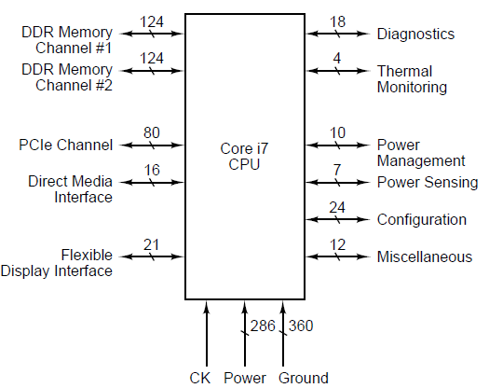

- 447 signals, 286 power connections, 360 grounds
- 1 DDR3 DRAM port
- PCIe channel to connect peripherals directly to the CPU
- DMI (Direct Media Interface): connects the CPU to its companion chipset
    - P67: SATA, USB, Audio, PCIe, Flash memory
    - ICH10: PCI interface, 8259A interrupt control, real-time clocks, event timers, DMA controllers
- Configuration:
configure interrupts in the same way as 8088 or use a new interrupt system: APIC (Advanced Programmable Interrupt Controller)
- Power management
- Heat management:
Thermal throttling: run the CPU only every Nth clock cycle.

Pipelining on the DDR3 Memory Bus
- Processors produce requests much faster than a slow DRAM can produce results. The problem is compounded with multiple CPUs.
- Solution: pipelining – 2 concurrent memory transactions
- 3 request steps:
    - Activate: open a new DRAM memory row
    - Read/Write: read 1 byte or sequential bytes
    - Precharge: close the row, prepare for the next Access
- 8 memory banks for parallel access
- Synchronous memory interface

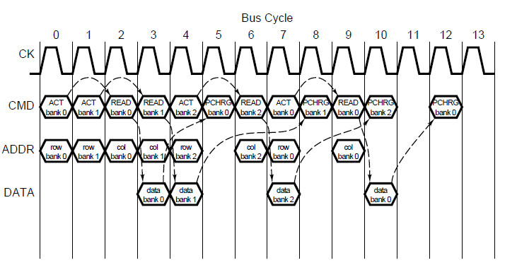

3.5.2 ULTRA SPARC III
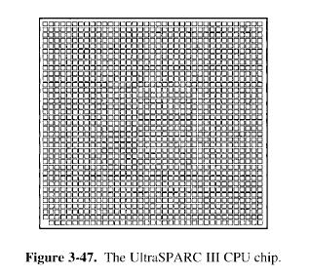

64 bit RISC architecture
Ultra Sparc I, II, III: different in clock speeds
VIS instructions for multimedia
Designed to be used in Sun’s core business, large shared memory multiprocessor servers used on the Internet and on corporate intranets. Much of the glue needed to build a multiprocessor is included inside the chip.
In 2000, 29 million transistors, 600 MHZ, 0.18 micron alimunium lines.
Texas Instrument manufactures the chips.
In 2001, 900 MHZ, 0.15 micron copper lines.
In 2002, 1.2 GHZ, 0.13 microns

New models: 4 memory ports

4 instructions per clock cycle can be issued
Superscalar architecture:
6 pipelines: 2 14 stage pipelines for integer operations
2 for floating point operations
1 for load/store
1 for branches.
Same cache mechanism with intel Core chips.

When the CPU needs a memory word, it first looks in one of its internal L1 caches for it. If it finds the word, it continues execution. If not, it tries cache 2.

All memory is divided into 64 byte cache lines. The most heavily used 256 instructions and 256 data lines -> L1 cache. Cache lines that are heavily used but which do not fit L1 cache are kept in L2 cache. L2 contains both data and instructions, mixed at random.
Tags: To keep track of which lines are in L2 cache.

3.5.3 The Texas Instruments OMAP4430 System-on-a-Chip

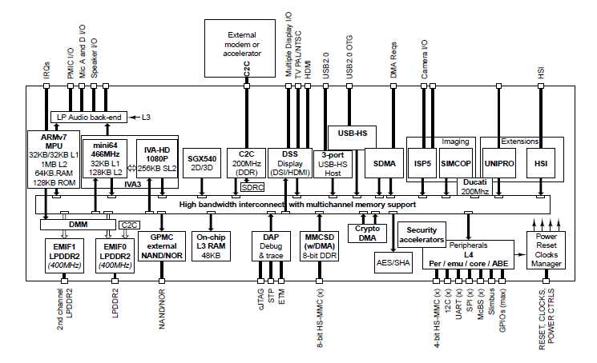

- İmplements ARM instruction set
- Targeted at mobile and embedded applications (smartphones, tablets etc.)
  - 2 ARM cores: 2 wide superscalar microarchitecture, 1GHZ, 45 nanometer linewidth
  - Additional accelerators:
    - POWERVR SGX540: graphics processor
    - ISP: image signal processor
    - IVA3: video processor
  - Peripheral interfaces:
Touchscreen, keypad, DRAM, flash, USB, HDMI
- An important design goal: reduce power consumption
  - Sleep modes
  - Dynamic voltage scaling: components run slower at a lower voltage
  - Power gating: more aggressive-power down a component

- Memory system:
- 2 L1 caches for each ARM A9 processor:32 KB data & instruction caches
- 1 MB L2 cache is shared by the two cores
- Caches are fed with 2 LPDDR2 low power DRAM channels (DDR2 interface)
- Memory is divided into 32 byte cache lines.
- 1024 lines in L1 data and instruction caches.
- 32768 lines in the unified L2 cache
- If the data is not in caches: 19 cycles to get it from memory: programmers should optimize their programs to use less data, making it more likely to find in L1 cache.
- LPDDR2 DRAM is directly connected to OMAP4430
  - Activate: send row address
  - Read/Write: send column address
  - While waiting for the results, CPU may contiune with other work. For ex., a cache miss while prefetching an instruction does not inhibit the execution of one or more instructions already fetched. Multiple transactions on 2 LPDDR2 interfaces may be outstanding.
  - Data arrives in 4 bytes at a time.
  - Burst read/write is allowed
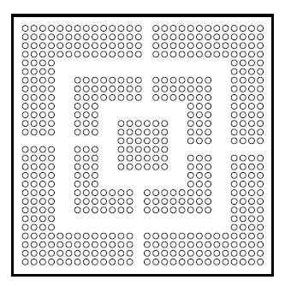

***Comparison with Core i7 and OMAP4430
    - Core i7 is CISC, OMAP4430 is RISC
    - 2 ARM A9 cores have a peak execution speed of 5 instructions per cycle, giving it almost the same execution rate as that of Core i7’s 4-core processor.
    - However, Core i7’s clock speed is 3.5 times faster.
    - When Core i7’s battery is not high, OMAP4430 may run faster

3.5.4 The Atmel ATmega168 Microcontroller

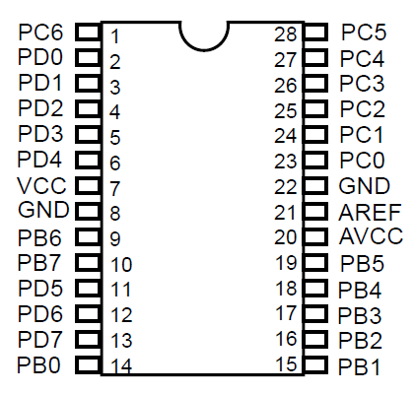

- For embedded systems
- Very cheap: 1 dollar
- 28 pin package: no address and data lines – the chip is not designed to be connected to memory, only to devices. All of the memory, SRAM and flash is contained within the processor.
- 27 digital IO ports: 8 lines in port B and D, 7 lines in port C- designed to be connected to I/O peripherals. Each line can be internally configured by startup software to be input or output.
6 lines of port C: for analog IO

- A SoC architecture:
Up to 16 KB flash memory for storage of infrequently changing nonvolatile information such as program instructions
Up to 1 KB EEPROM for system configuration data (driver).
- Instruction set:
AVR instruction set: 131 insructions, each 16 bits in length
8 bit processor, operations are on 8 bit data
Special instructions for operations on larger data.

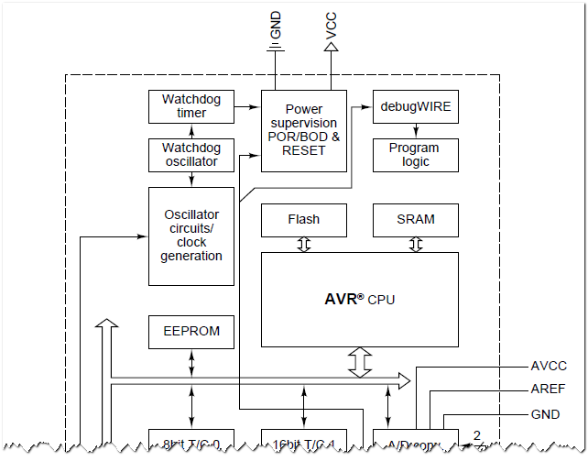
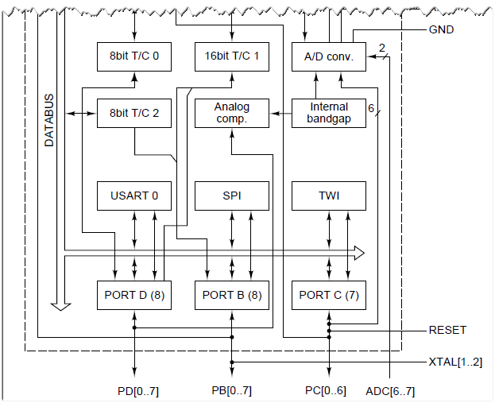

3.6 EXAMPLE BUSES

1. PCI Express (PCIe)
2. USB

3.6.1 PCI bus

  - Old IBM PC bus was text based. New applications were pixel based with large bandwidth demand and put much strain on early system buses such as the ISA bus.

1024 x 768 x 3 bytes/pixel x 30 frames → 135 MB/sec bus bandwidth is required
HD resolution: 1920x1080 → 155 MB/sec
ISA bandwidth: 16.7 MB/sec
EISA bandwidth: 33.3 MB/sec

1990-PCI- Peripheral Component Interconnect: Intel put the patent into public domain

Original PCI: 133 MB/sec
PCI 2.0, PCI 2.1
PCI 2.2 : for mobile computers (battery considerations)
PCI bandwidth: 528 MB/sec, 64 bit transfers
Problems with PCI bus:
- not good enough for memory bus
- not compatible with ISA cards
Solution: 3 buses

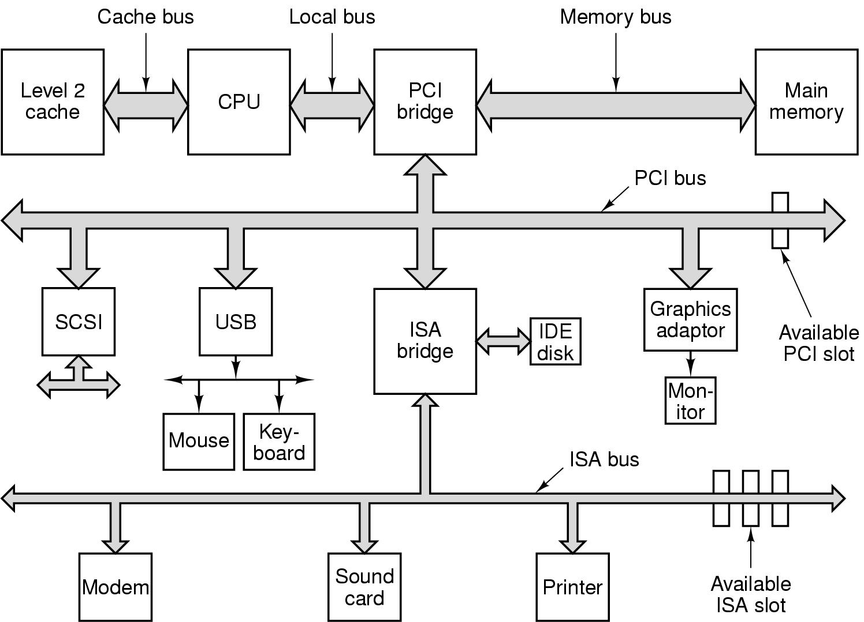
By the late 1990s, ISA was dead
AGP bus (Accelerated graphics port bus) for video and games
AGP 1.0: 264 MB/sec
AGP 3.0: 2.1 GB/sec.
AGP bus is usurped by PCIe: 16 GB/sec

Modern Core i7 bus system:
Connected directly to the CPU are
- 2 DDR3 memory channels for main memory: 10 GB/sec per channel
- 16 lane PCIe: 16 GB/sec to I/O devices

CPU is connected to P67 via 20 GB/sec serial Direct Media Interface (DMI).
P67 provides interfaces to modern high performance I/O interfaces:
- 8 additional PCIe lanes
- SATA disk interfaces
- 14 USB 2.0 interfaces
- 10G Ethernet
- Audio interface
ICH10 provides legacy interface for old devices. It is connected to P67 with DMI:
- PCI bus
- 1 G Ethernet
- USB ports
- Old style PCIe and SATA Interfaces

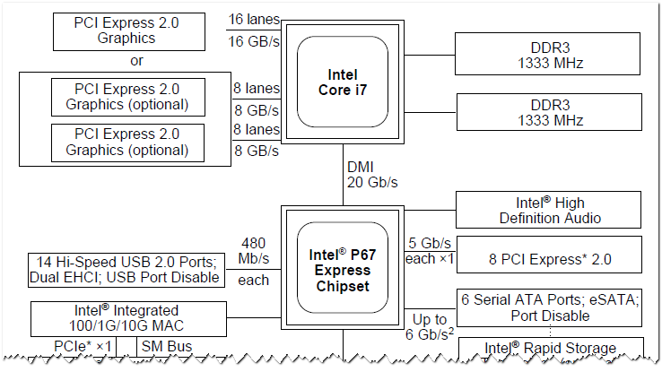

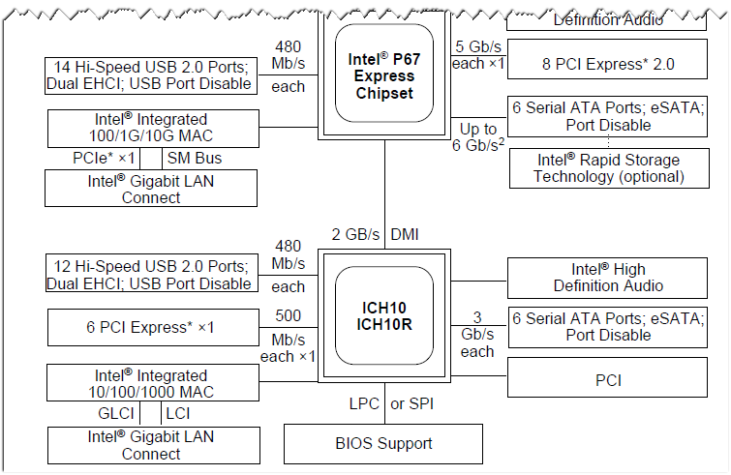

PCI bus operation:
PCI is a synchronous bus
Multiplexing to reduce the number of pins
Centralized bus arbiter

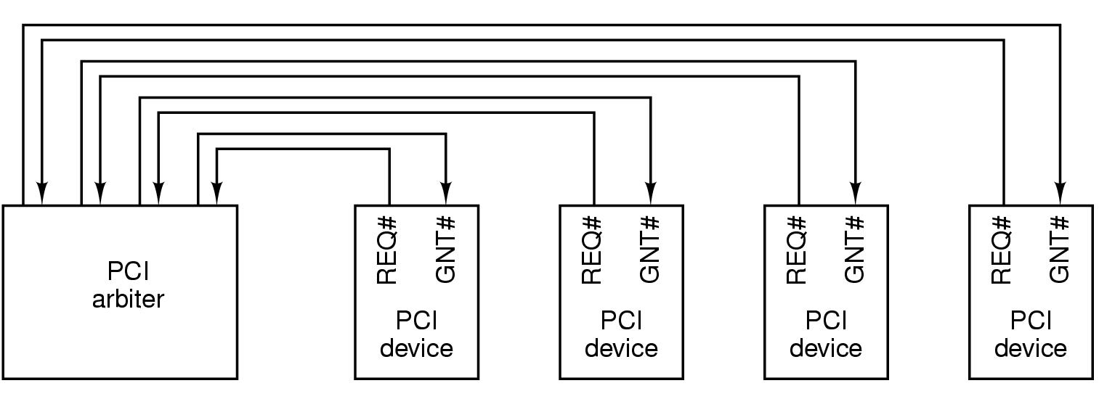

PCI Express:
Problems with PCI:
1. There are increasingly many IO devices that are too fast for the PCI bus. Every time an IO device gets too fast for the PCI bus, Intel adds a new special port to the bridge chip to allow that device to bypass the PCI bus.
2. PCI cards are quite large. They do not fit into laptop computers and palms.

Solution: PCI Express

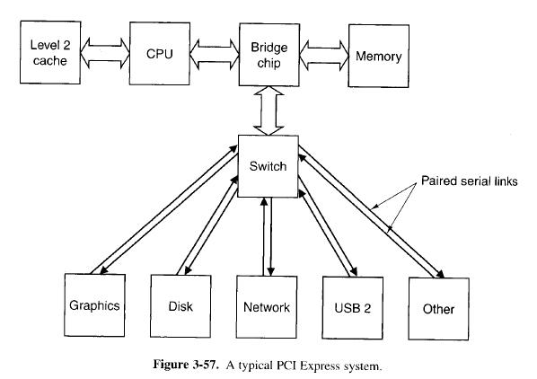

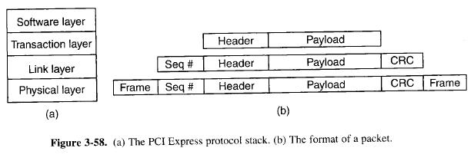
Idea: to get rid of the paralel bus with its many masters and slaves and go to a design based on high speed point to point serial connections.
  - centralized switch versus a multidrop bus
  - use of a narrow serial proint to point connections versus a wide paralel bus.
  - PC turns into a miniature packet switching network.
  - Reliability due to error detection codes
  - Connection between a chip and the switch is longer than it was, up to 50 cm, to allow system partitioning
  - The system is expandable, allowing a tree of switches.
  - Devices are hot pluggable
  - Since the serial connectors are much smaller than than the old PCI connectors, devices and connectors can be made much smaller.
PCI Express Protocol Stack

Physical layer: move bits from one sender to a receiver
Unlike ISA/EISA/PCI buses, PCI Express does not have a master clock. 8b/10b encoding is used for synchronization.

Link Layer: Packet transmission
CRC control
Flow control for speed discrepancies between the sender and the receiver.

Transaction Layer: handle bus actions. Reading a word requires 2 transactions.
Establishes upto 8 virtual circuits for each link, each for a different traffic class

Software Layer: interfaces the PCI Express to OS: OS independency

Difference between networking and PCI Express:
In networking: layers are part of the OS
In PCI Express: Layers are part of the device hardware

3.3 USB

1. Users must not have to set switches or jumpers on board or devices.
2. Users must not have to open the case to install new I/O devices.
3. There should be only one kind of cable, good for connecting all devices.
4. I/O devices should get their power from the cable.
5. Upto 127 devices should be attachable to a single computer.
6. The system should support real-time devices.
7. Devices should be installable while the computer is running.
8. No reboot should be needed after installation.
9. The new bus and its I/O devices should be inexpensive to manufacture.

USB 1.0: 1.5 Mbps (for keyboard and mice)
USB 1.1: 12 Mbps (for printer, digital camera…)
USB 2.0: 480 Mbps (for external disk drives, hd webcams, network interfaces)
USB 3.0: 5 Gbps (compatible to USB 2.0 devices)

A USB system consists of a root hub that plugs into the main bus. This hub has sockets for cables that can connect to IO devices or to expansion hubs to provide more sockets: The topology of a USB system is a tree with its root at the root hub, inside the computer.
3.7. SERVER ARCHITECTURES snd BUSES

3.7.1 İNTEL XEON PHI SERVER PROCESSOR CHIP

-Supports upto 61 cores with 8 memory controllers each with 2 memory channels.

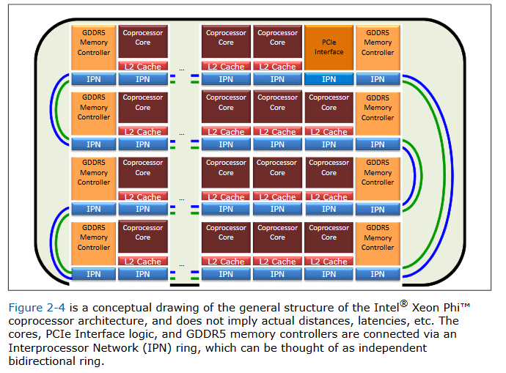

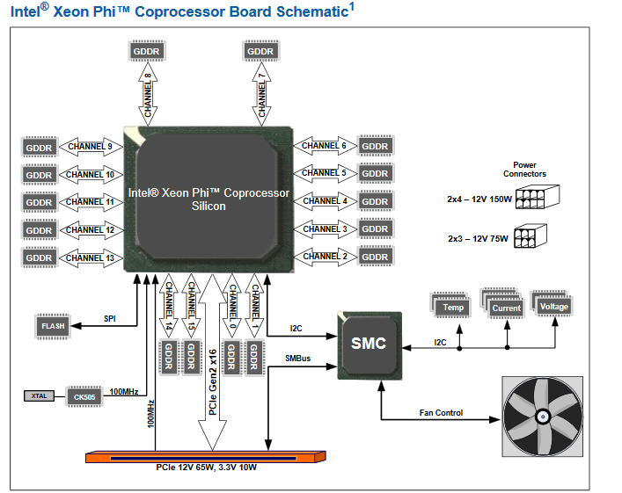

- Static configuration with SMC (System Management Controller)

System Interconnect:
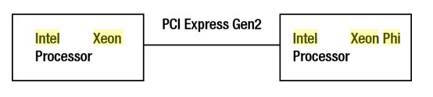

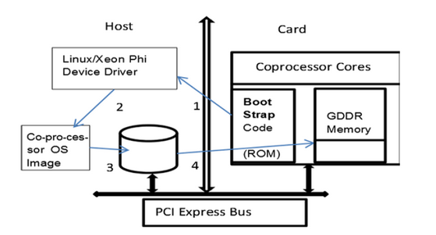

Virtualization is absent. This is a performance drawback for BIG-DATA operations.

    - SPARC T5-2 SERVER PROCESSOR CHIP

-SPARC T5 processors provide dual on-chip PCIe Generation 3 (Gen3) interfaces.
-Dynamic configuration with FPGA.
-Last model T7 servers include on chip support for database query acceleration through hardware compression/decompression and security for cryptography.
-Virtualization: For clustering many processor cards. Virtualization software is developed by Oracle itself

